
College Search Tools

Student Reference Guide

Overview
Naviance Student can help make the process of finding the right college just a little easier. Using Naviance Student’s Find your Fit search tools, you can locate the schools that most fit with your interests, passions, and criteria. Once you’ve narrowed down a group of colleges, multiple tools are available to understand more about that school in general and as a prospect. This document is meant to help you understand how to search for, favorite, and research colleges of interest.
Naviance Student provides two features to store college information:
- Colleges I’m Thinking About: This is a list of schools that you have favorited and identified as prospective schools of interest.
- Colleges I’m Applying To: This is a list of schools to which you have decided to apply. This can be populated from College’s I’m Thinking About or directly from searches.

Find Your Fit Tools
The first step of this process is figuring out what schools may be a good fit for you based on your interests. Naviance Student offers seven (7) search tools – SuperMatch ™, College Match, College Events, Scattergrams, Advanced College Search, and College Lookup.
To access Find Your Fit Tools, go to Colleges, locate the Find Your Fit column, and select the search tool of your choice.

SuperMatch™
Use SuperMatch™ to receive a list of best-fit schools based on criteria that you deem as important in your college search. SuperMatch™ can be used to save searches and return to them later. To learn about the details of using SuperMatch™, please review the SuperMatch Reference Guide.
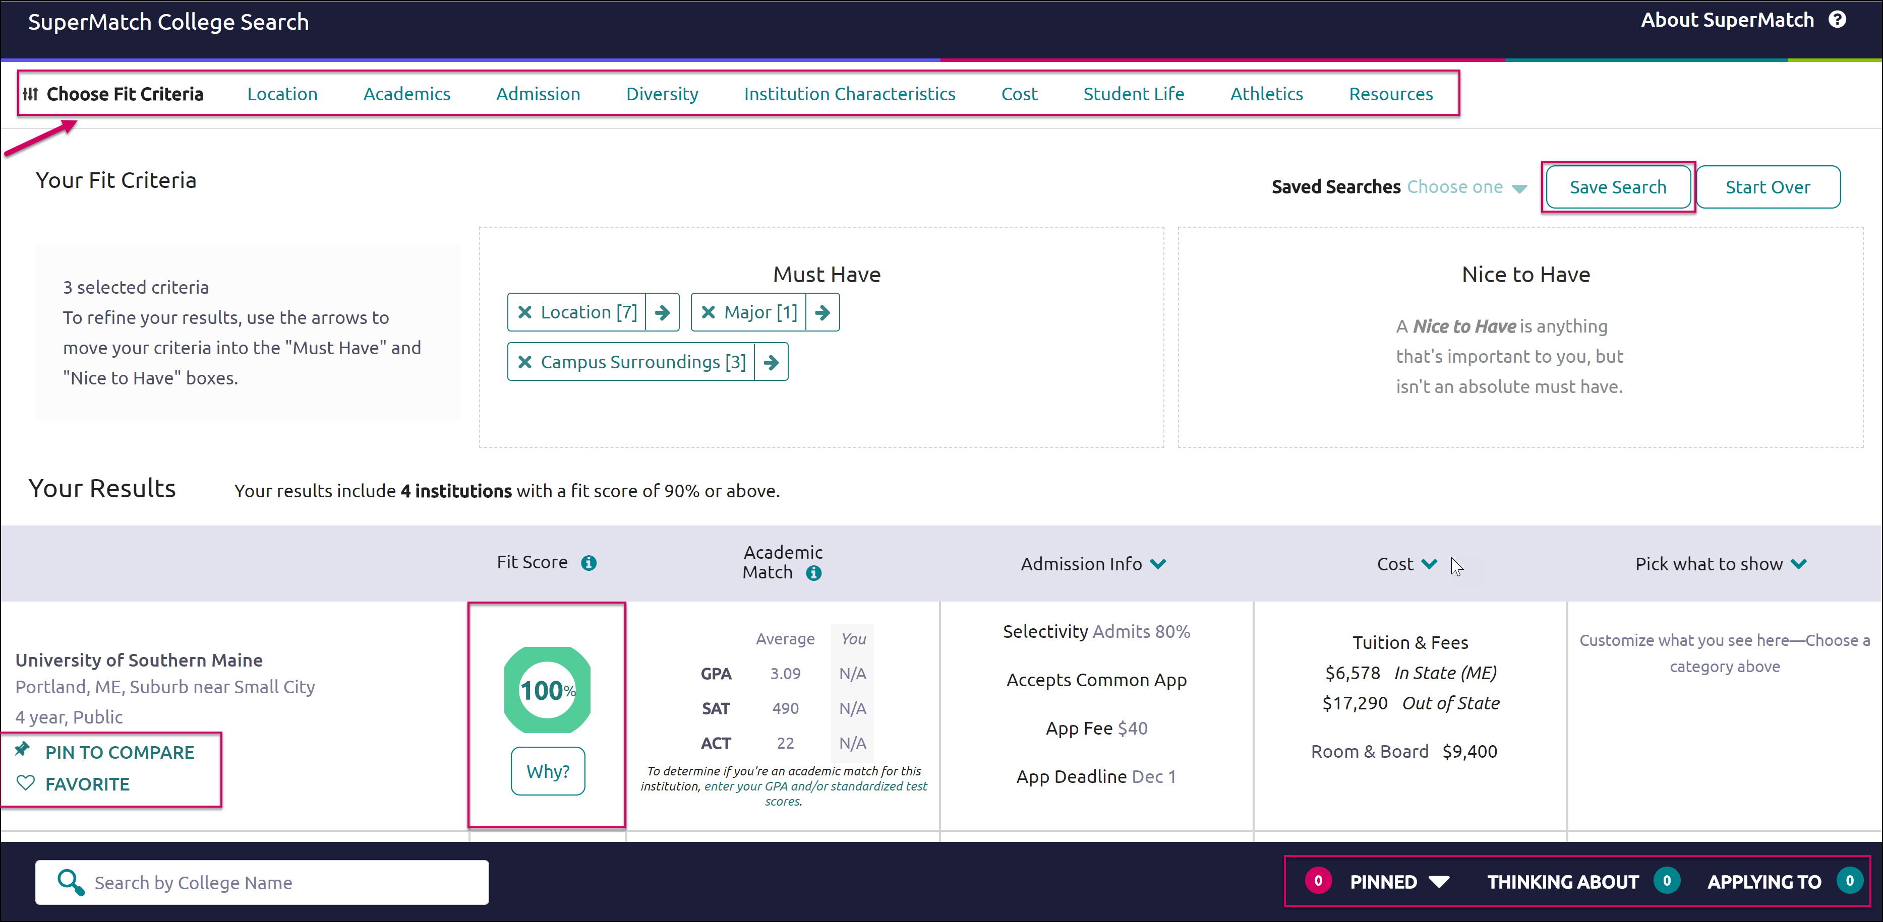
- Choose Fit Criteria: Use best fit criteria drop-downs such as Location and Academics to get matched with the schools that are the best fit for you.
- Pin to Compare: Use the pin feature to keep an eye on schools you are interested in.
- Favorite: Add schools to the colleges you are thinking about in Naviance Student.
- Compare: Use the Pinned drop-down to Compare pinned schools based on factors important to you.

College Match
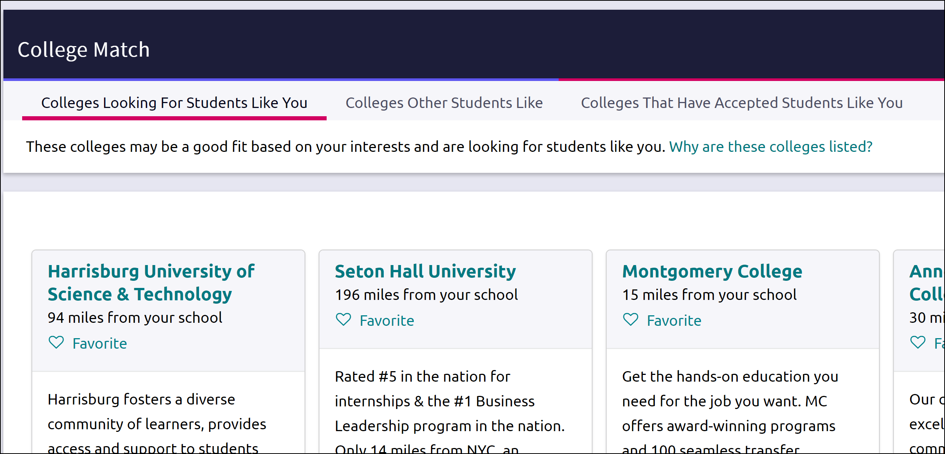
See and quickly favorite the other schools that are:
- Looking for Students Like You
- Colleges Other Students Like
- Colleges that Have Accepted Students Like You

College Events
View a list of colleges that are hosting events and sign up for those of interest.
- Browse events and sign up in Naviance Student.
- Look for a “Recommended for you” flag. These colleges are looking for students like you!
- Use More Options to apply advanced filters and match yourself to colleges with selected criteria.
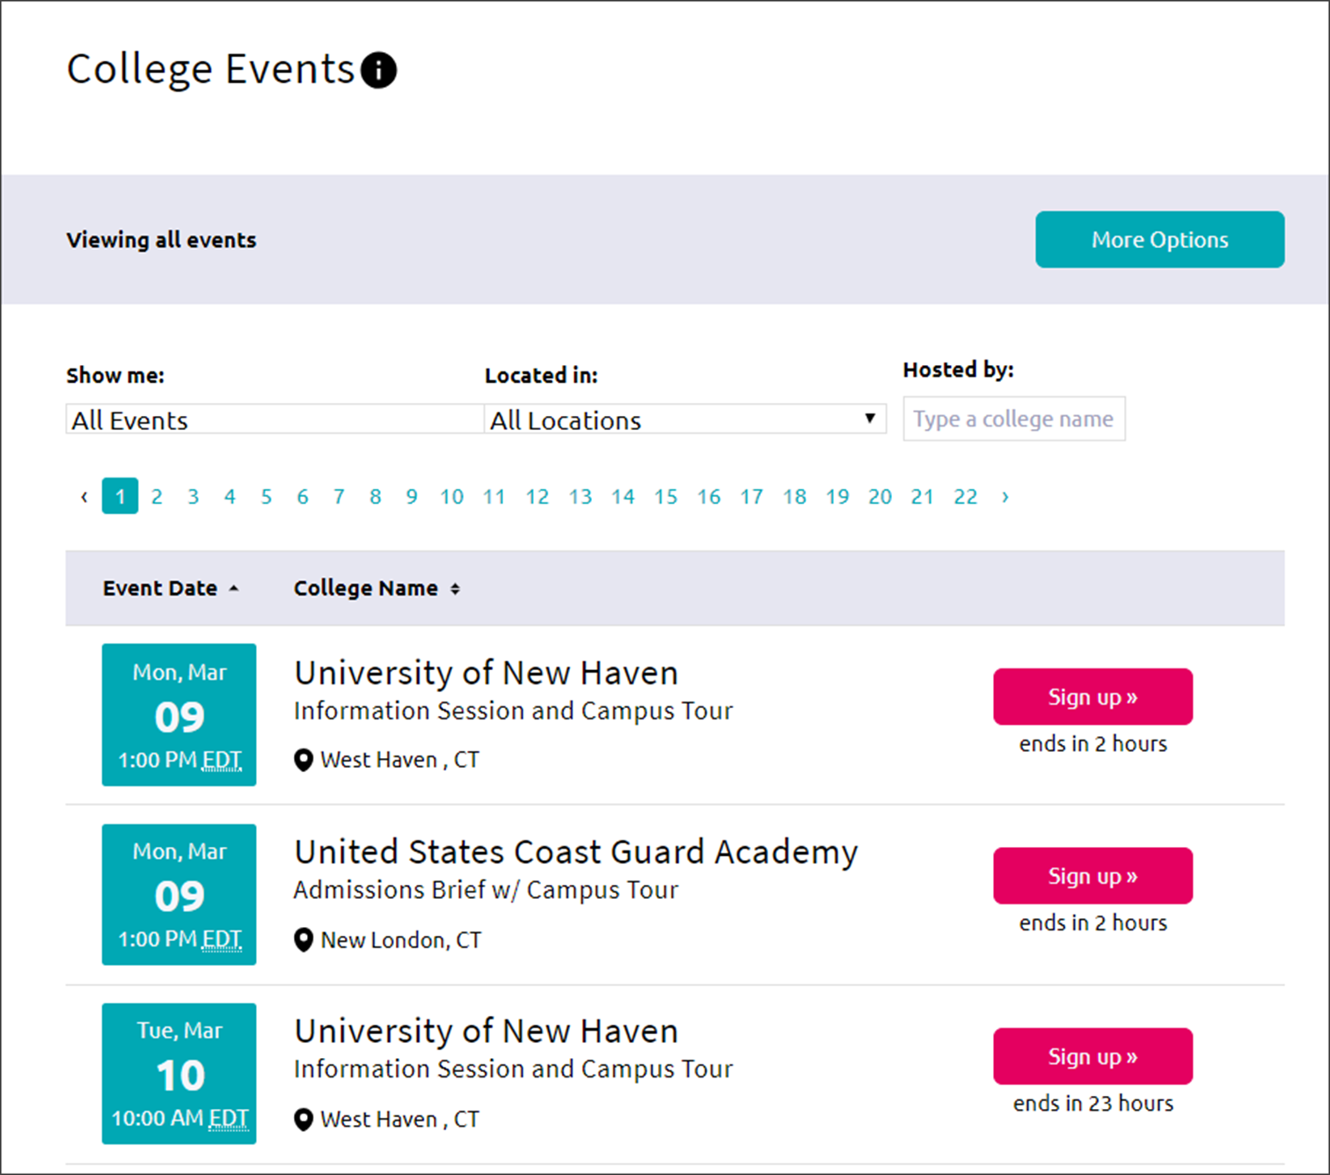

Scattergrams
A scattergram is a graph used to help you analyze how you fit in with other students from your high school who have been accepted, waitlisted, or denied admittance to a school based on GPA and test scores.
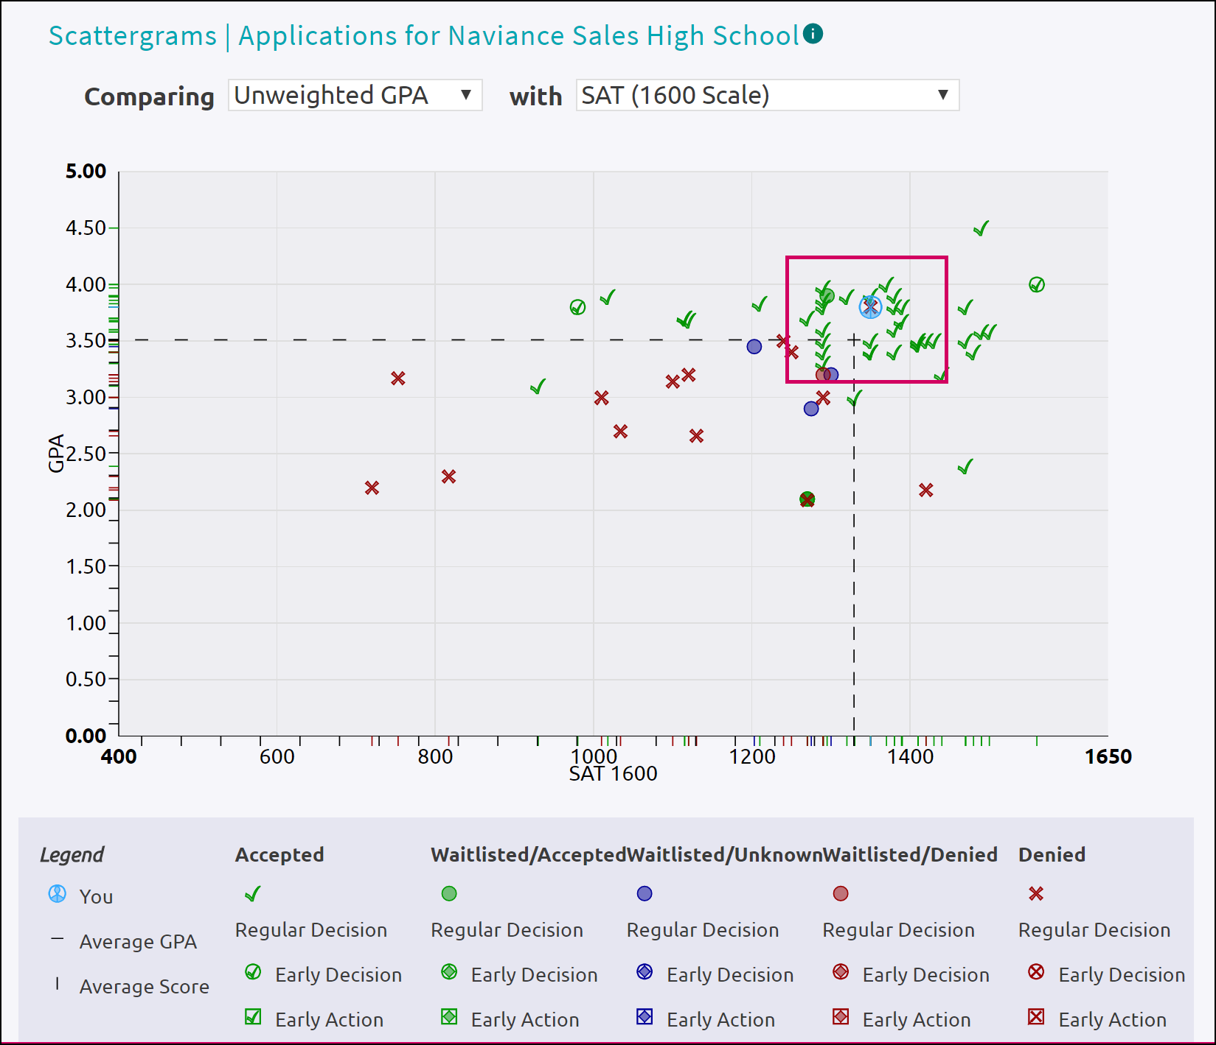
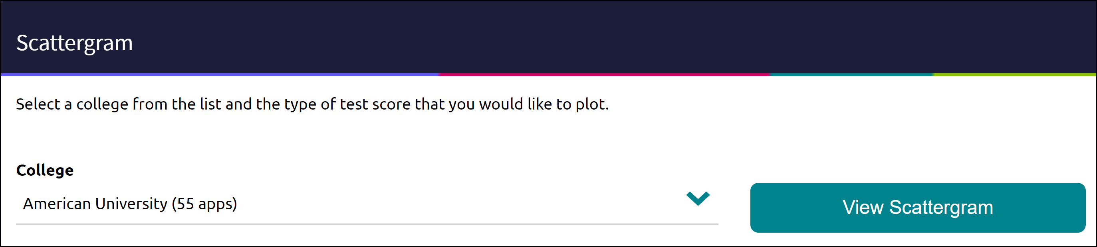
- Select a college from the dropdown list. The number in parentheses shows how many other students from your high school, historically, have applied to this school.
- Click View Scattergram.
The scattergram for this school displays.
- Change the Comparing and with dropdown menus to make sure you are comparing the right information.
- Use the legend to view those accepted, waitlisted, and denied. Your data shows as a light blue circle. Hover over a data point to see connected SAT and GPA information.

Advanced College Search
Using multiple categories, answer questions to identify colleges that match your interests.
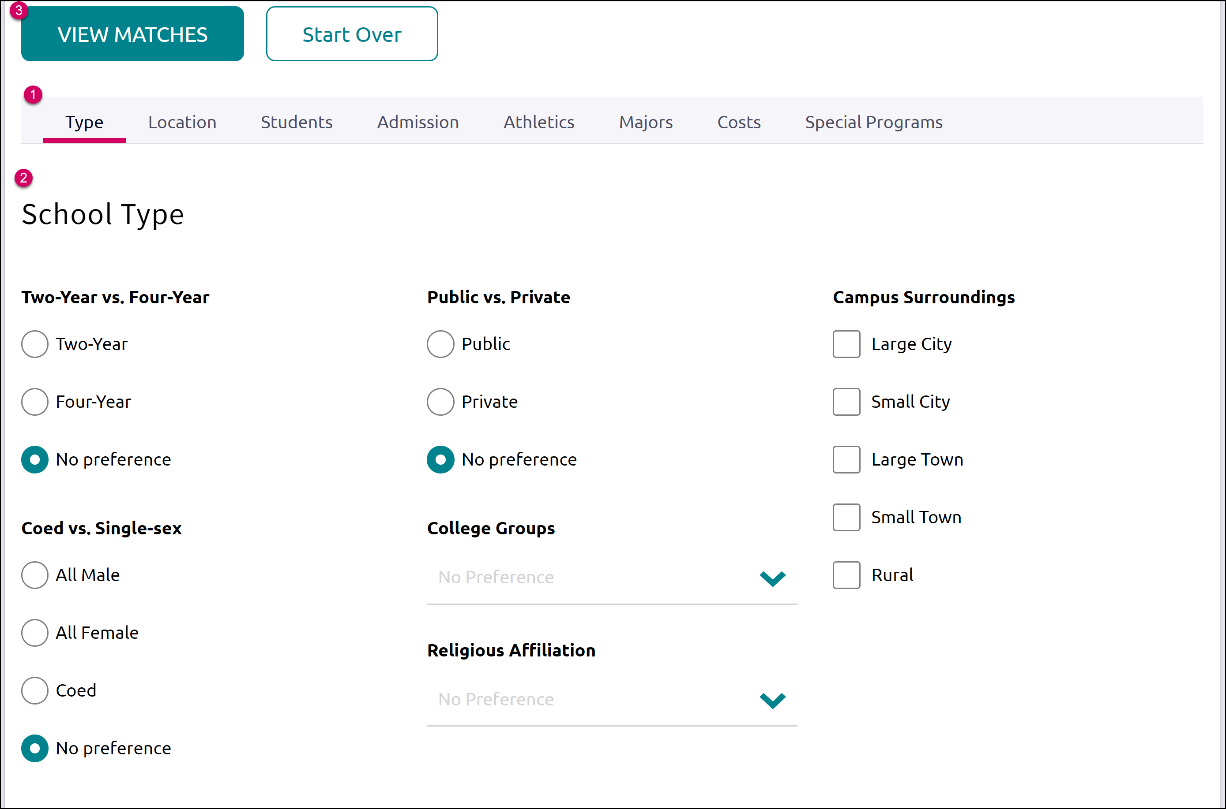
- Click on a category, i.e., Location or Majors.
- Answer category-related questions and identify your preferences for a school.
- Click View Matches.
A list of schools that match your criteria displays.
- Click the checkbox(es) next to the school(s) depending on what action you want to take next.
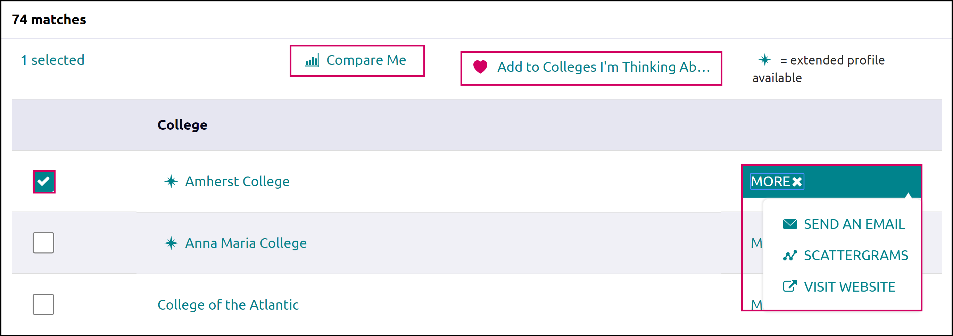
- From here, you can choose to use Compare Me, Add to Colleges I’m Thinking About (Favorite), Send an Email to the school, view a Scattergram for the school, or visit the school’s website.
- From our results list, click Save Search to save this search criteria.
- Next time you return, go to the Saved Searches dropdown menu and find your saved search.

College Lookup
Lookup and favorite school(s) by multiple filters including name, country, state, or college group. Easily favorite using the heart symbol next to the college.
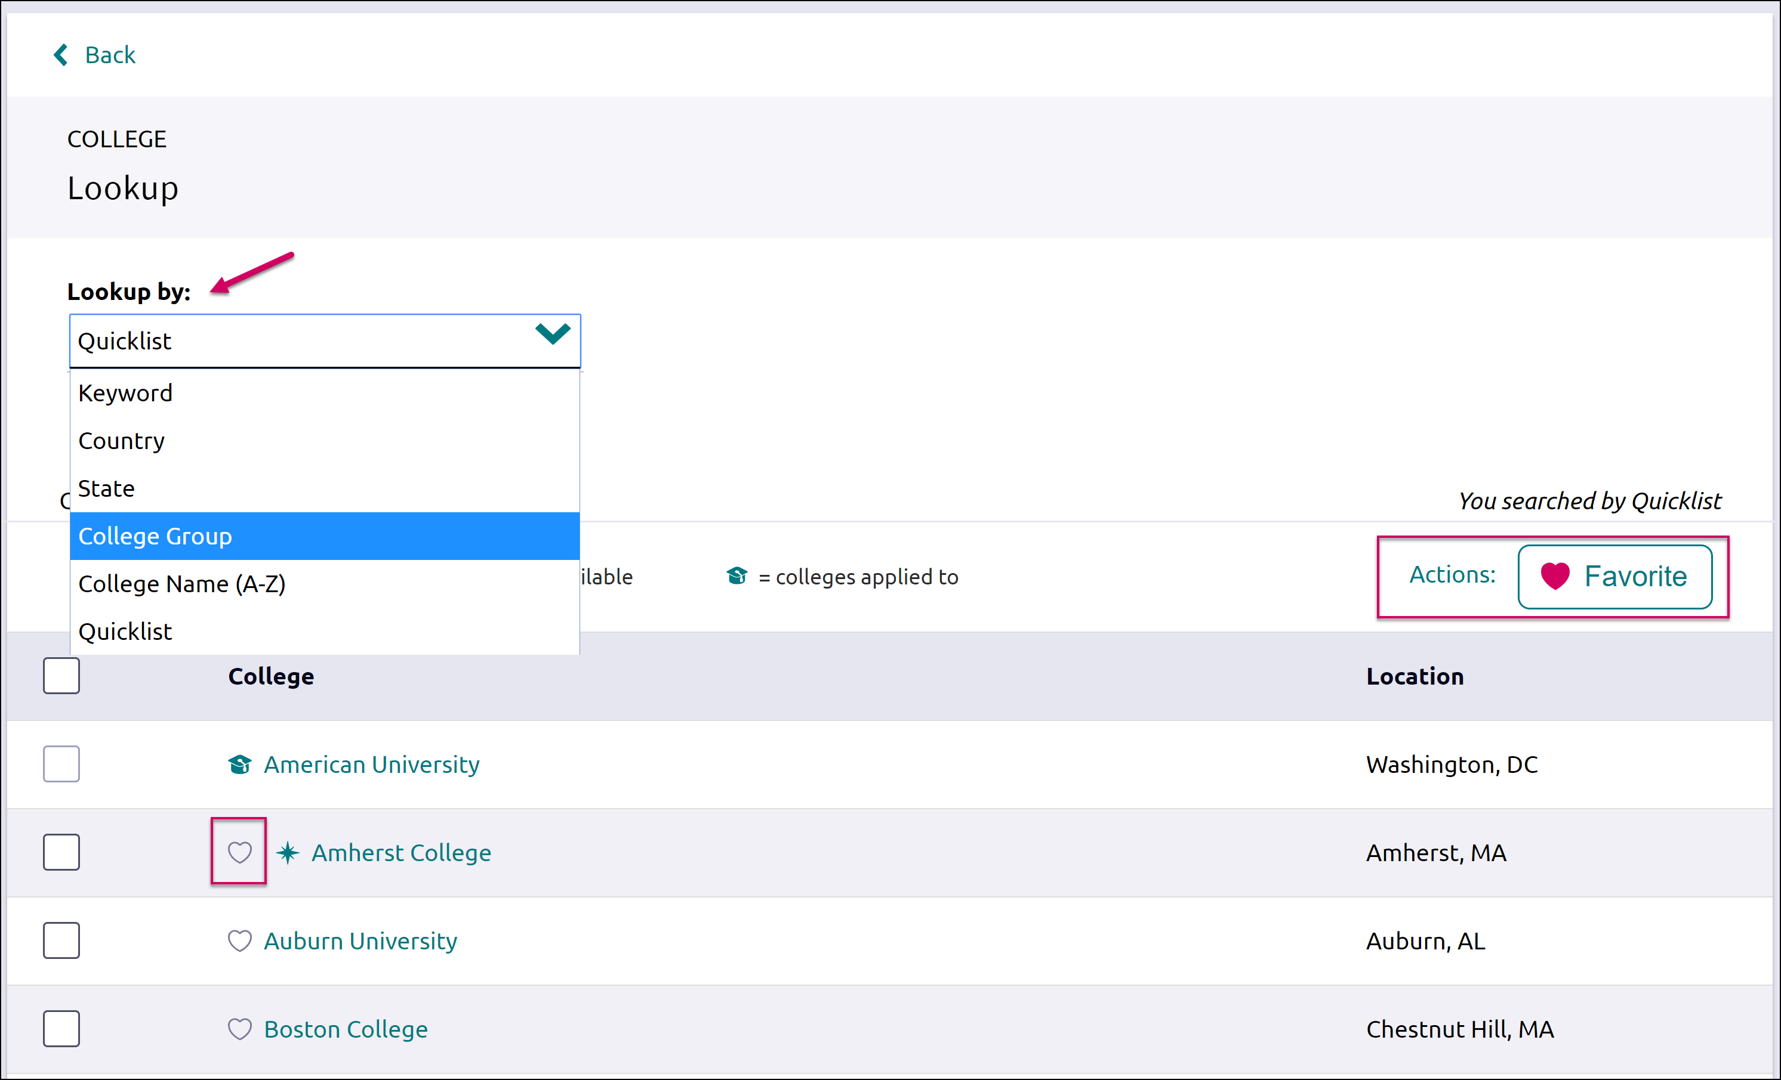

College Profile Pages
When a search is completed, the schools that are a part of the results can be researched further by accessing the college’s profile. From a search result, click the college of interest to open its college profile.
- Click the heart icon to favorite the school and add it to your list of Colleges I’m Thinking About.
- Use the tabs (Overview, Studies, Student Life, etc.) to learn more about these areas.
- Communicate, Apply Online, or Learn More using the provided buttons on the page.
- Located at the bottom of the page, use the buttons to navigate to those areas specified in Naviance Student (Colleges I’m Thinking About, Applying To, etc.).
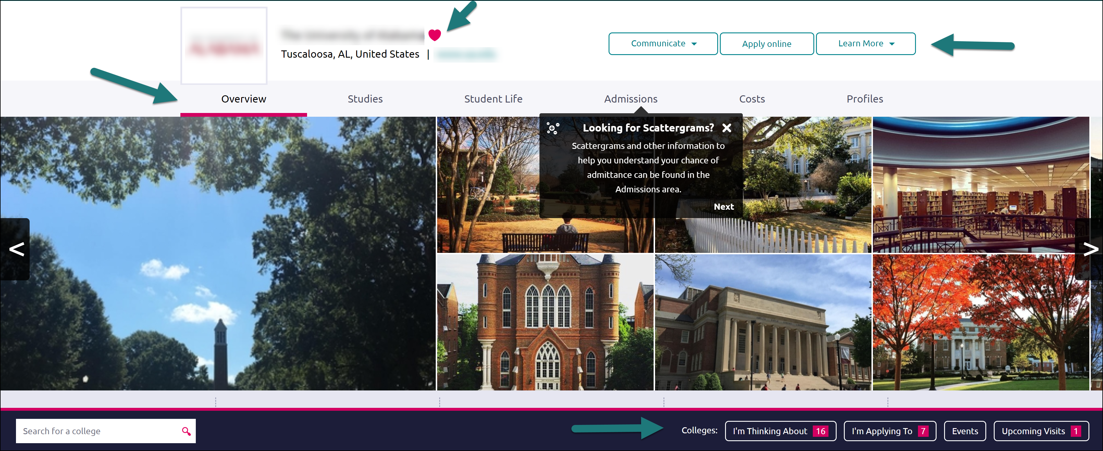

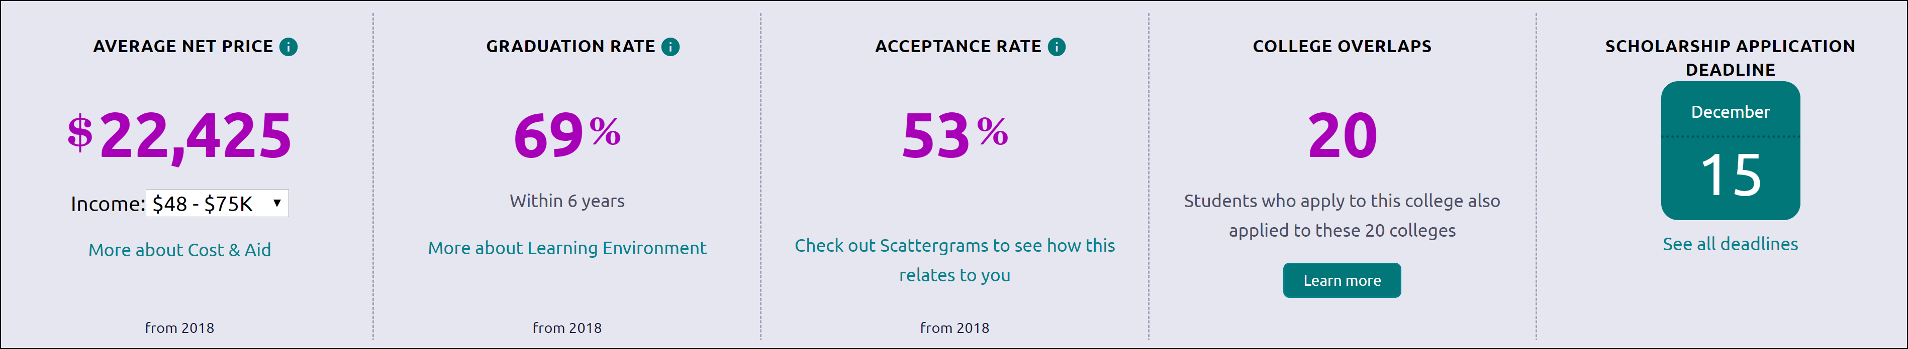
The Overview tab provides general information about the school, including the information seen below.
You can find Scattergrams and other admission information on the Admissions tab.


College Research
You have found some schools you are interested in and now you are ready to learn even more. From the Colleges section, under Research Colleges, you can find multiple tools for researching schools and your likelihood of admittance.

- College Compare
- College Resources
- Acceptance History
- Enrichment Programs
- College Maps

College Compare
Add schools to compare the average GPA and test scores of students from your high school that have been accepted to that college over a span of time.
- Click Add Colleges to Compare.
- Use the College Lookup to find schools.
- Click the checkbox (es) next to the schools to which you’d like to see a comparison.
- Click Save Selection in the upper-right corner.
- Click Finished Searching.
The schools are added to your Compare list. A green check means your numbers are higher and a red x means they are lower than average for those who have been admitted to this school.
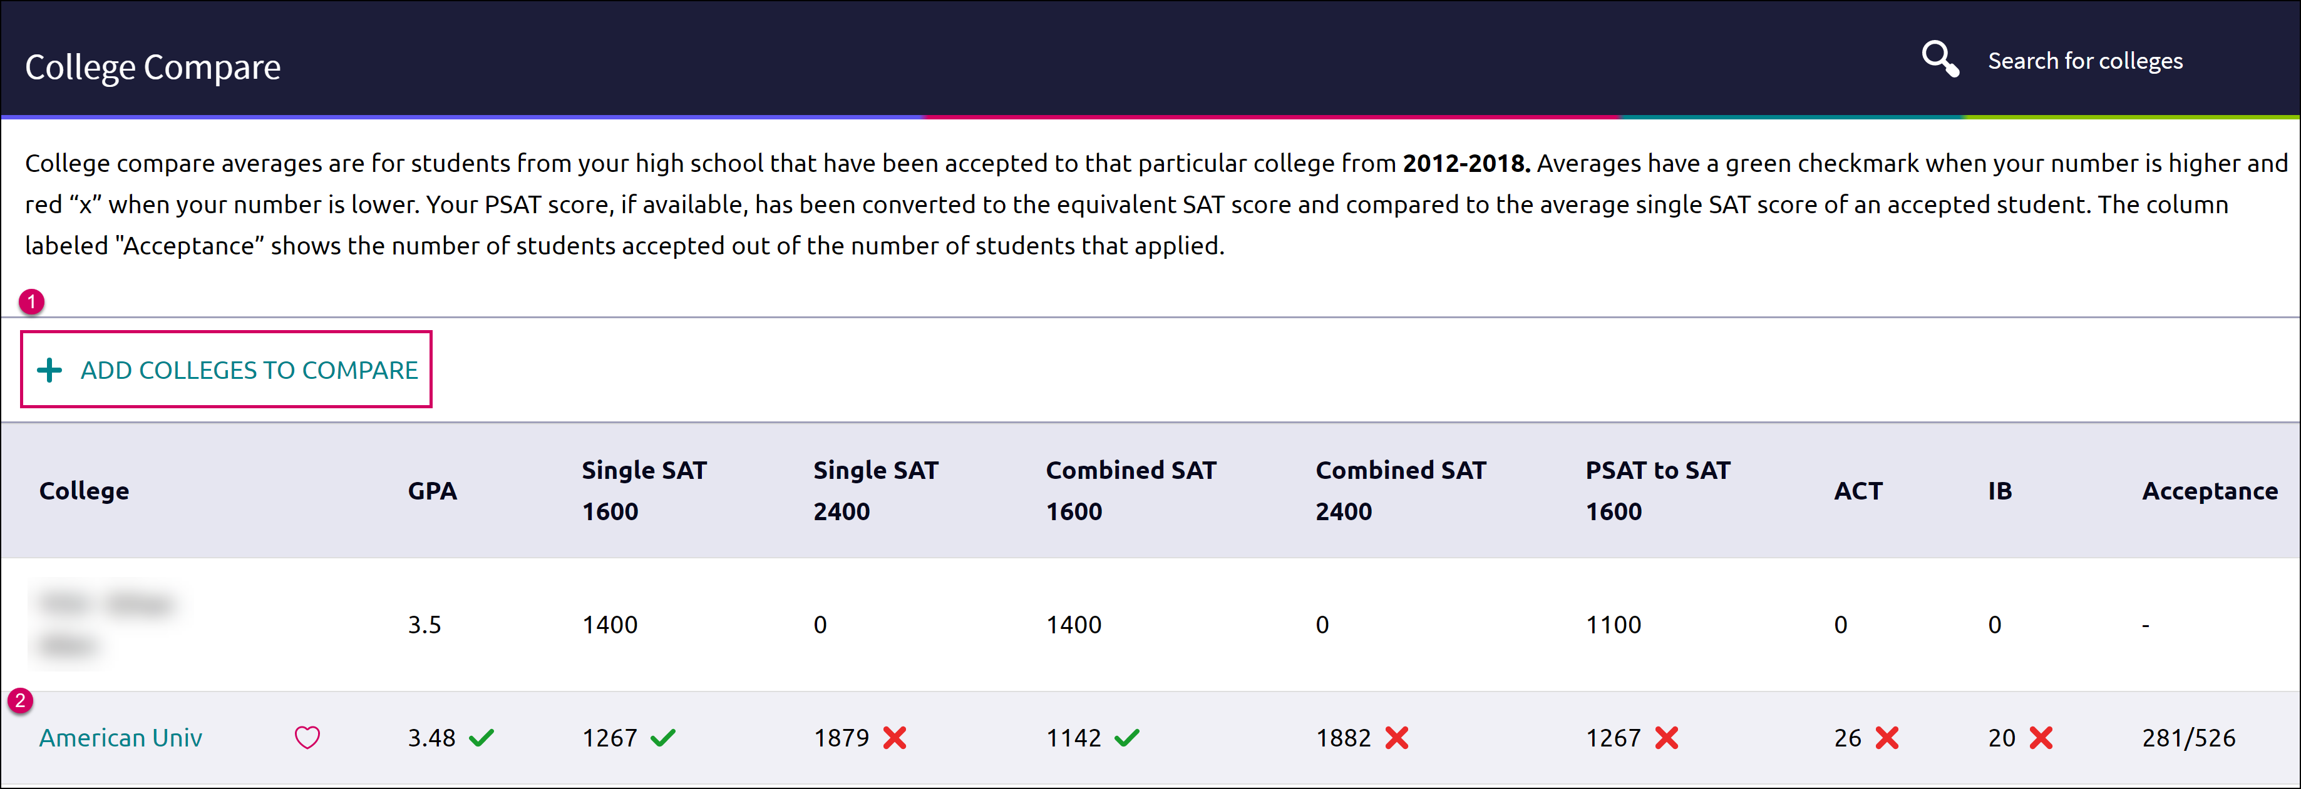

College Resources
List of external web resources that may be valuable to your college search process. Sections include Colleges & Careers, Financial Aid, Test Preparation, College Athletics, and Military.

Acceptance History
An alphabetical list of colleges where someone from your school has been accepted and/or enrolled over a time span.

Enrichment Programs
Locate enrichment programs provided by your school to view extracurricular opportunities in your community.

College Maps
View an interactive map of schools based on a list of different pre-defined criteria. For example, you can see a map of the colleges from your Colleges I’m Thinking About list. Some other map categories include Top 20 most popular colleges where our students applied, colleges where our students are attending, 5-year combined BA/MBA, and more.
